
Dr Gemma Kirkland- GP Partner
MBChB MRCGP DRCOG

Tel: 01698 284 353 Dr Nicandro Pacitti- GP Partner
BSc (Med Sci) MBChB MRCGP DRCOG
Web: www.portlandparkmedicalcentre.co.uk
Dr Hannah Chapman- GP Partner
MBChB MRCGP

Dr Zina Mula- Salaried GP
MBChB MRCGP

Dr Corrinne Hogg- Salaried GP
MBChB MRCGP

Dr Murray Will- Salaried GP
MBChB MRCGP

If you have already registered for Patient Services but cannot login

STEP 1: RECOVER YOUR USERNAME

- Visit www.patient-services.co.uk

- From the login screen, click ‘Need help accessing your account?’
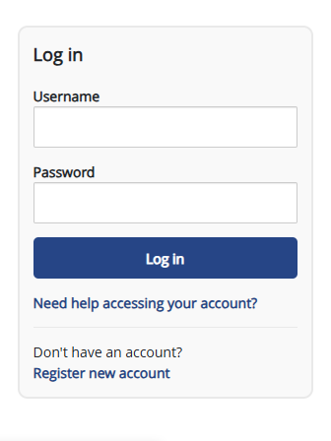
- From the menu displayed, click on, ‘I have forgotten my username’

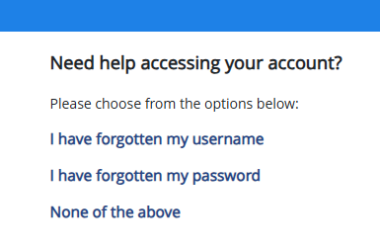

- At the next screen, enter the email address you registered the account with. You will then be sent an email with your username information

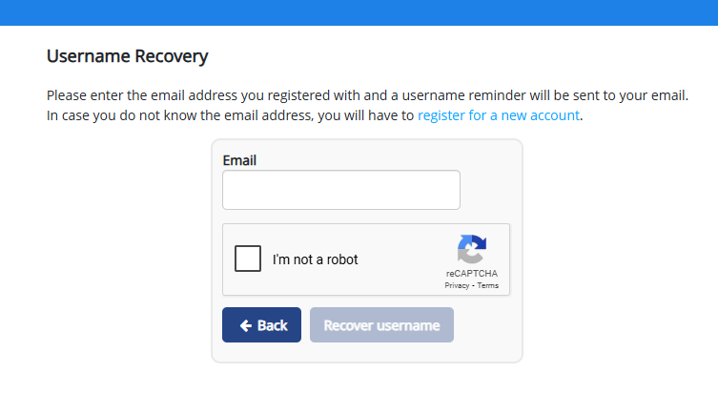

STEP 2: RE-SET YOUR PASSWORD

- Follow steps 1 & 2 outlined above

- From the menu displayed, click on, ‘I have forgotten my password’

- At the next screen, enter the username you have registered the account with (this will have been emailed to you following the steps listed above)

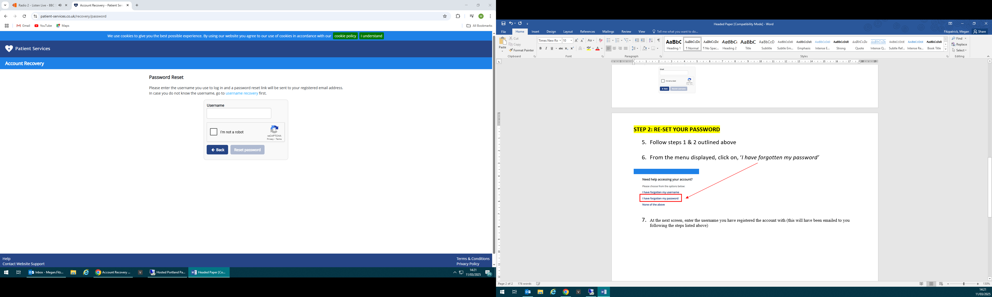
- When you have entered your username and reset your password, you will receive a copy of this via email

- Return to the login screen and use your recently re-set username and password to login to your account

